Week4

1)
class Student{
public String name;
Student(String name){
this.name=name;
}
public String toString(){
return name;
}
}

public class Ex3{
public static void main(String[] args){
//declares an array and initializing the elements of the array
Student[] myStudents = new Student[]{
new Student("Dharma"),new Student("sanvi"),new Student("rupa"),new Student("ajay")
};
for(Student m:myStudents){
System.out.println(m);
}
}
}
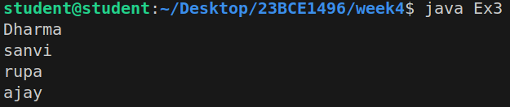

2)
public class Ex4 {
public static void main(String[] args){
int[] arr={10,20,30,40};
System.out.println("Trying to access element outside the size of array");
System.out.println(arr[5]);
}
}

3)
public class Ex5 {
public static void main(String[] args){
int[][] arr= new int[10][20];
arr[0][0]=1;
System.out.println(arr[0][0]);
}
}

4)
public class Ex6 {
public static void main(String[] args){
int[][][] arr= new int[10][10][10];
arr[0][0][0]=1;
System.out.println(arr[0][0][0]);
}
}

5)
public class Ex7{
public static int sum(int arr[]){
int sum=0;
for(int m:arr){
sum+=m;
}
return sum;
}
public static void main(String[] args) {
int arr[]={3,1,2,5,4};
System.out.println("Sum of array values: "+sum(arr));
}
}

6)
public class Ex8 {
public static int[] m1(){
//returning array
return new int[] {1,2,3};
}
public static void main(String[] args){
int arr[] = m1();
for(int i=0;i<arr.length;i++){
System.out.println(arr[i]+" ");
}
}
}

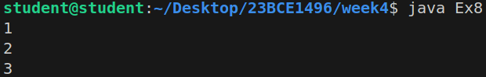

7)
public class Ex9 {
public static void main(String[] args) {
int intArr[] = new int[2];
byte byteArr[] = new byte[2];
short shortArr[] = new short[2];
String stringArr[] = new String[2];
System.out.println(intArr.getClass());
System.out.println(intArr.getClass().getSuperclass());
System.out.println(byteArr.getClass());
System.out.println(shortArr.getClass());
System.out.println(stringArr.getClass());
}
}
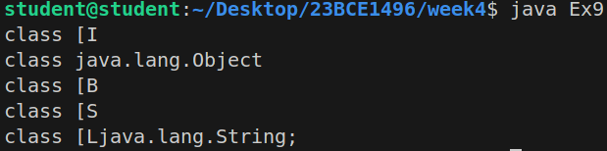

8)
public class oneDArrayCloning{
public static void main(String[] args){
int intArr[] = {1,2,3};
int cloneArr[] = intArr.clone();

//will print false as deep copy is created
//for 1D array
System.out.println(intArr==cloneArr);
for(int i=0;i<cloneArr.length;i++){
System.out.println(cloneArr[i]);
}
}
}
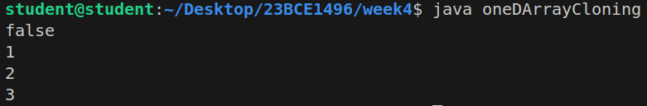

9)
public class multiDArrayCloning {
public static void main(String[] args){
int intArr[][] = {{1,2,3},{4,5}};
int cloneArr[][] = intArr.clone();

//will print false
System.out.println(intArr==cloneArr);
System.out.println(intArr[0]==cloneArr[0]);
System.out.println(intArr[1]==cloneArr[1]);
}
}

